**Exercise 3:**

**Main Task:**

**1.First, one person in the group should create a public repository using their GitHub account.**

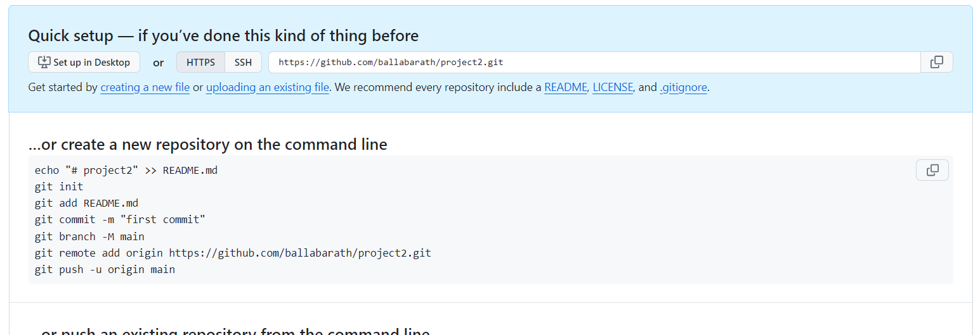

**2. This same person should then follow the instructions from GitHub to add a remote, and then push their repository. Do not forget the –u flag, as suggested by GitHub!**

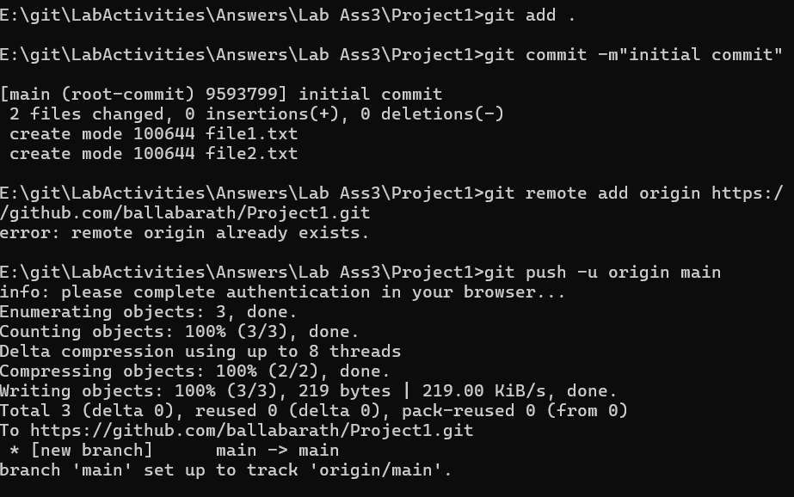

**3. All of the other members of the group should then be added as collaborators, so they can commit to the repository also.**

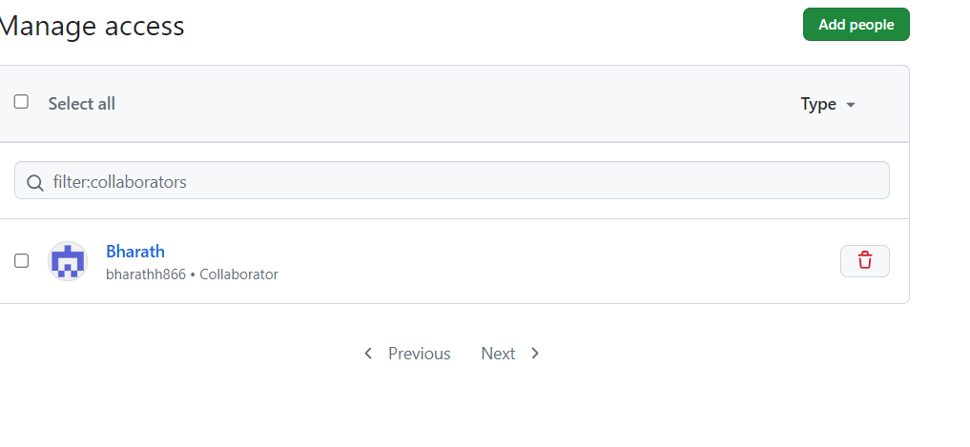

**4. Next, everyone else in the group should clone the repository from GitHub. Verify that the context of the repository is what is expected.**

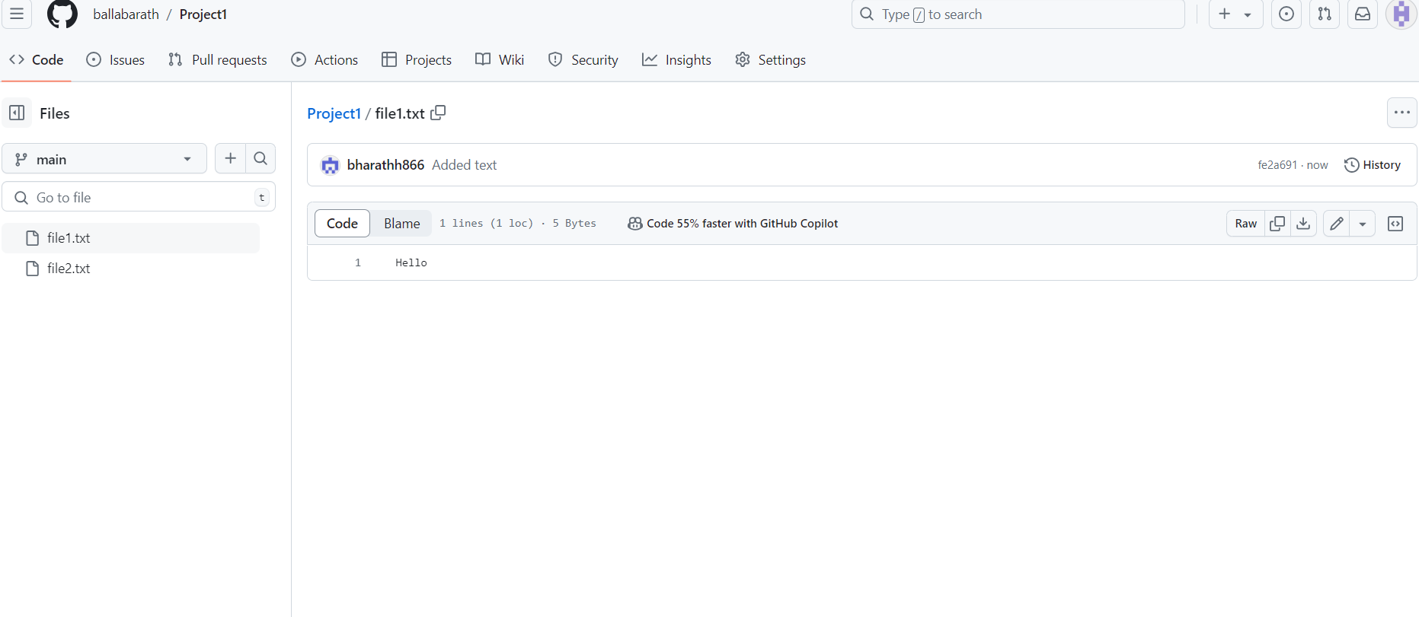

**5. One of the group members who just cloned should now make a local commit, then push it. Everyone should verify that when they pull, that commit is added to their local repository (use git log to check for it).**

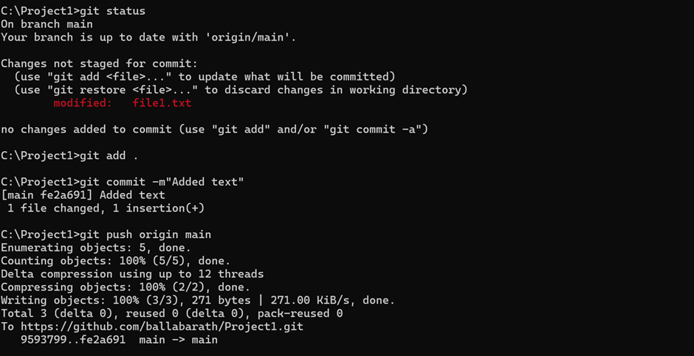

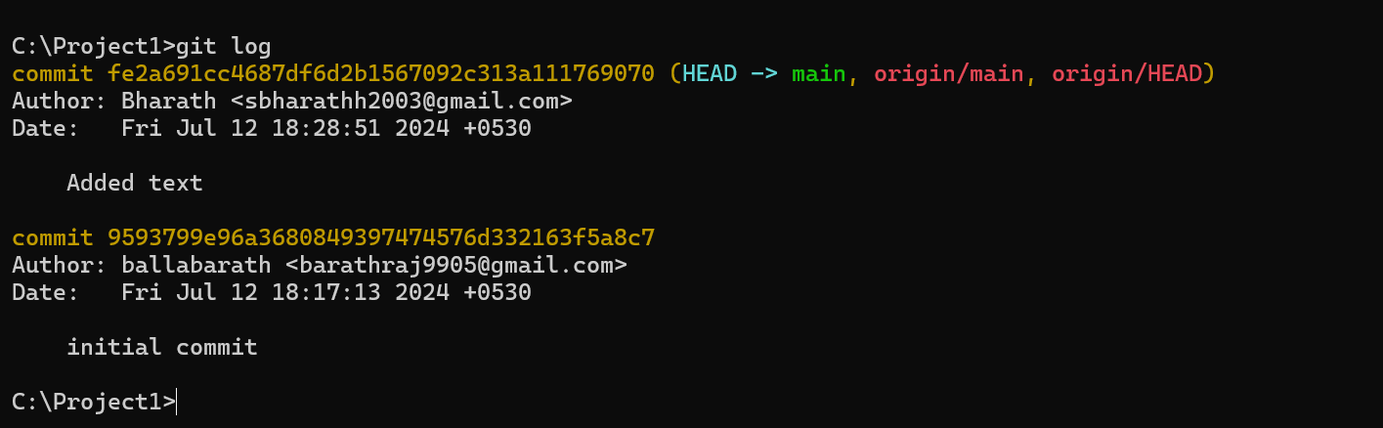

**6. Look at each other’s git log output. Notice how the SHA-1 is the same for a given commit across every copy of the repository. Why is this important?**

It is the reference for all the users working on it.

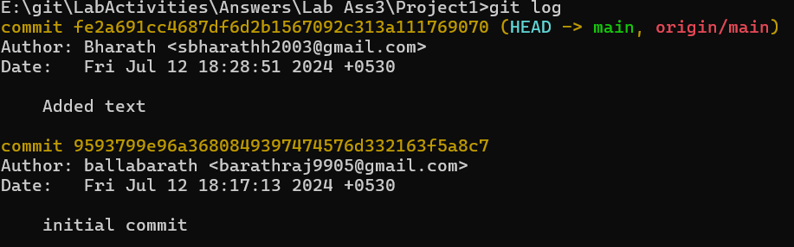

**7. Two members of the group should now make a commit locally, and race to push it. To keep things simple, be sure to edit different files. What happens to the runner-up?**

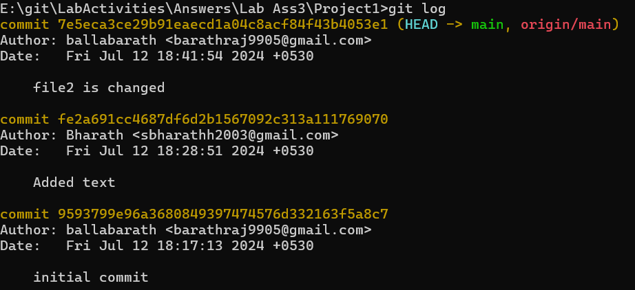**8. The runner-up should now pull. As a group, look at the output of the command. Additionally, look at the git log, and notice that there is a merge commit. You may also wish to view the DAG in gitk.**

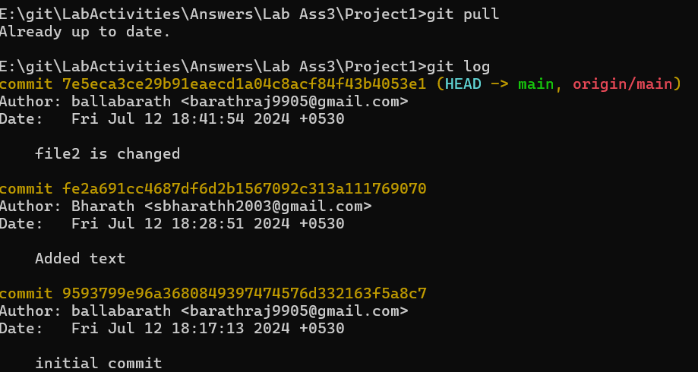

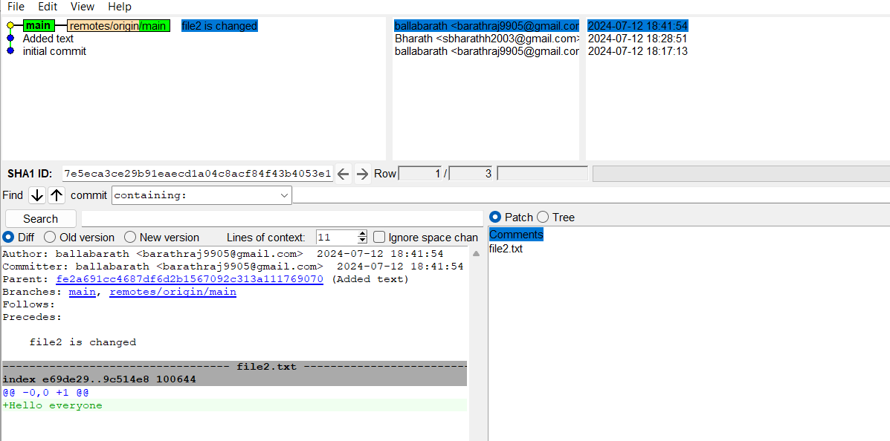

**9. Repeat the last two steps a couple of times, to practice.**

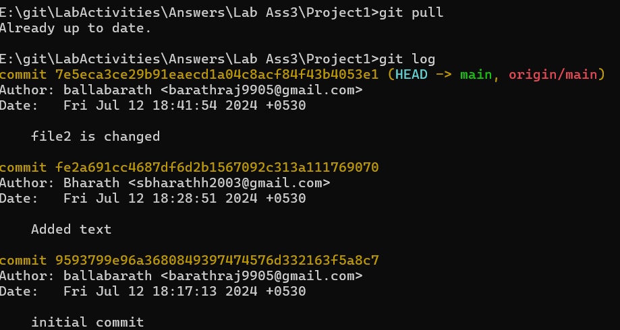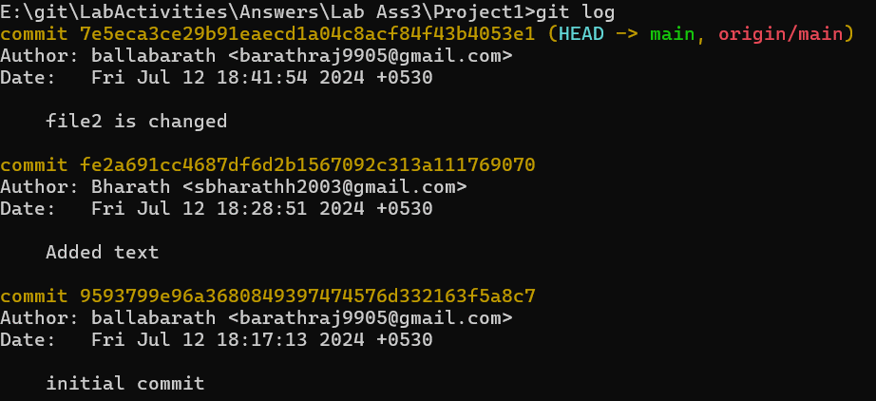

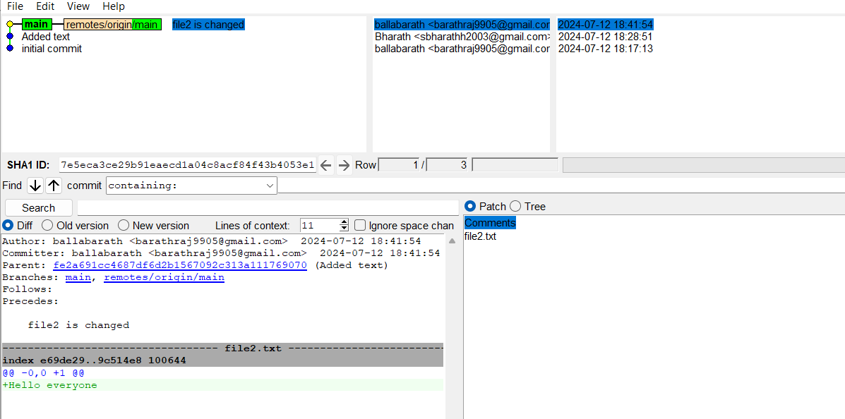

**Exercise 4**

**Main Task**

1.Make a commit, and make a silly typo in the commit message.

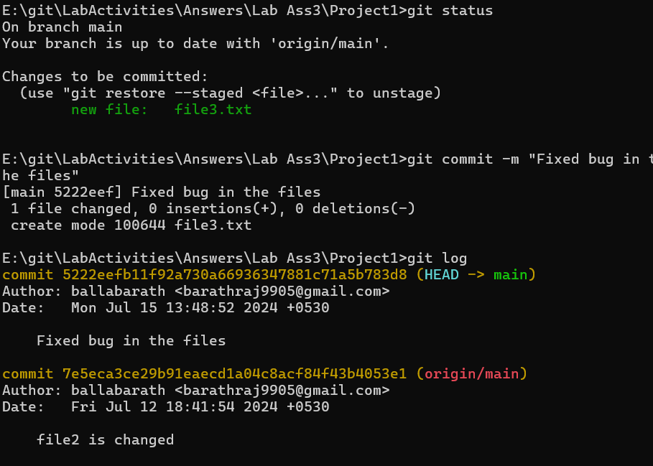

2. Use the **--amend** flag to enable you to fix the commit message.

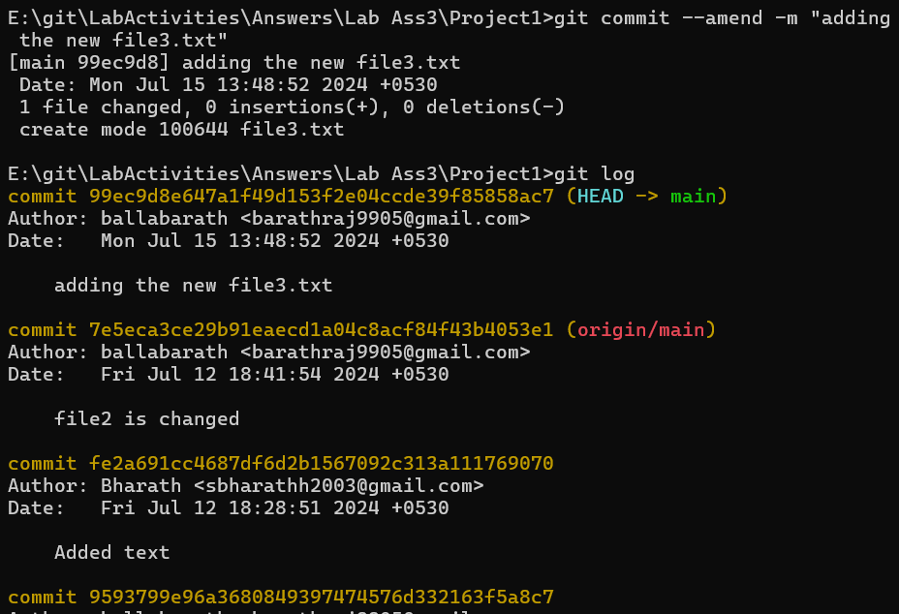

3. Look at the **log** and notice how the mistake is magically gone.

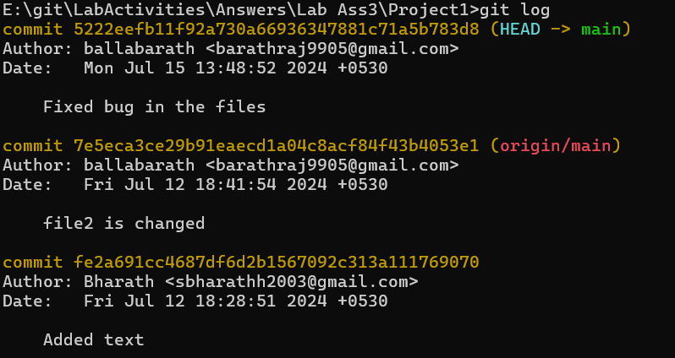

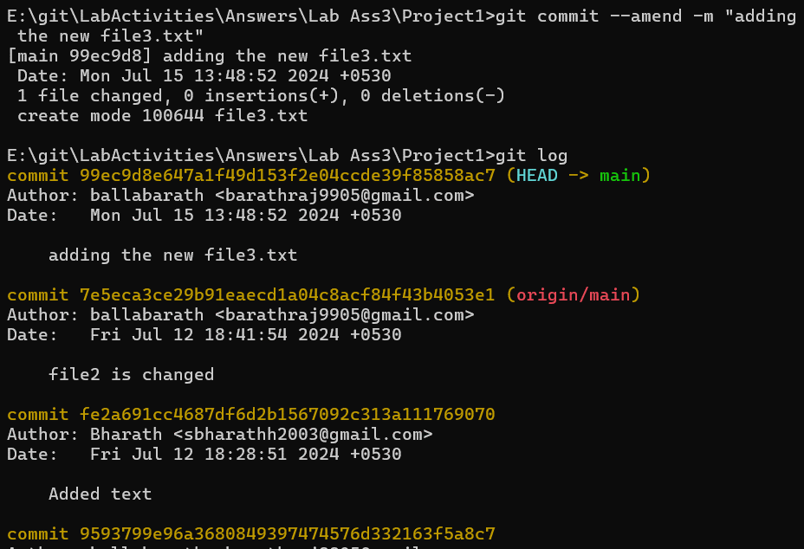

4. Now make a commit where you make a typo in one of the files. Once again, use **--amend** to magic away your problems.

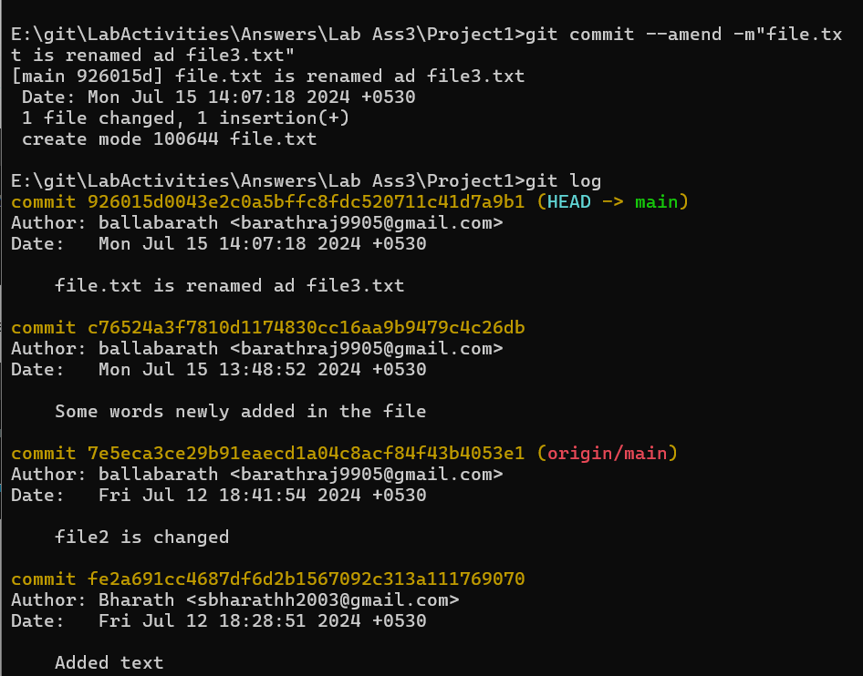

5. Create a branch. Make a commit.

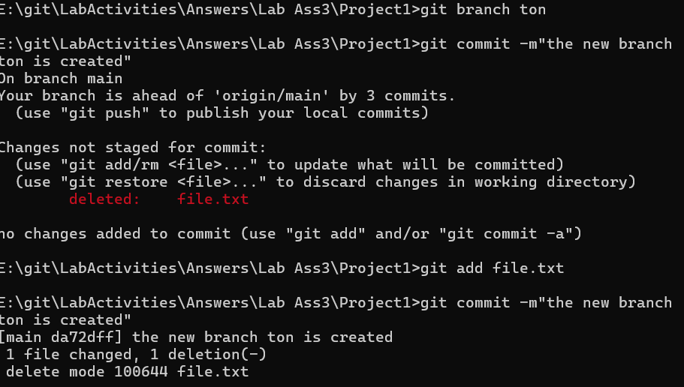

6. Now switch back to your master branch. Make a (non-conflicting) commit there also.

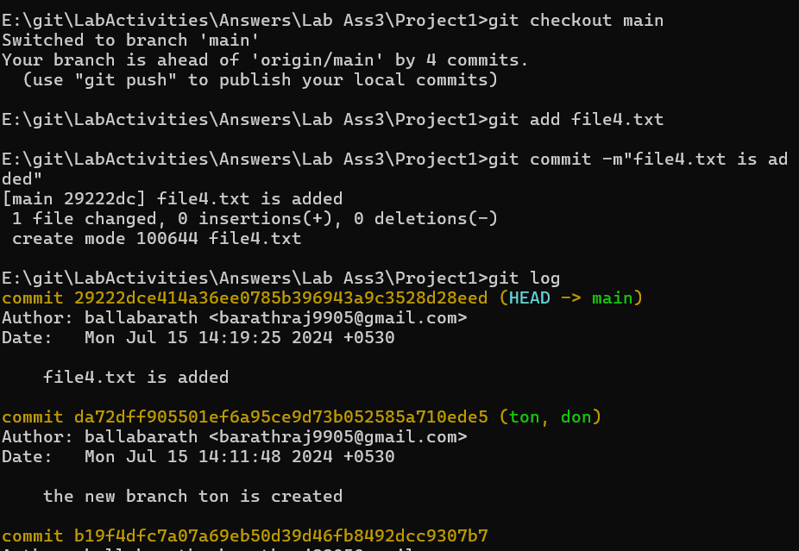

7. Now switch back to your branch.

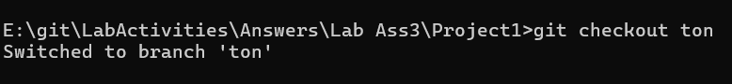

8. Use the **rebase** command in your branch. Look at the DAG in **gitk**, and note that you have the

commit from the master branch, but no merge commit.

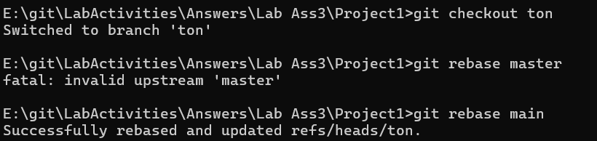

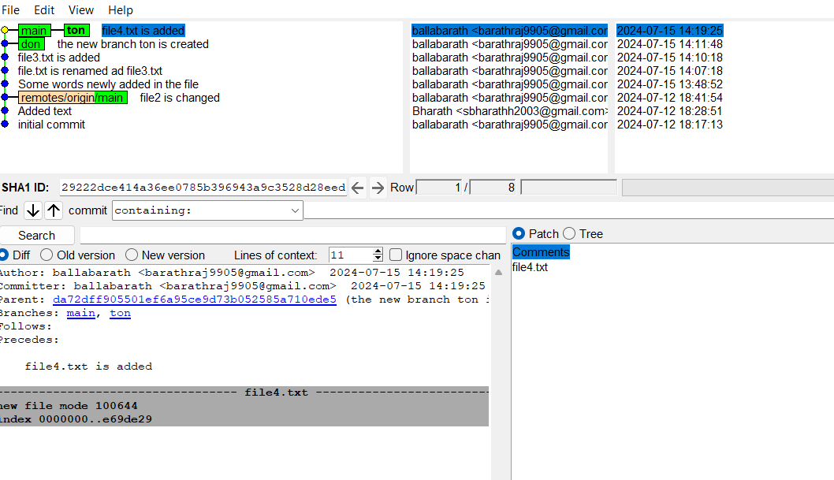

9. Make one more commit in your branch.

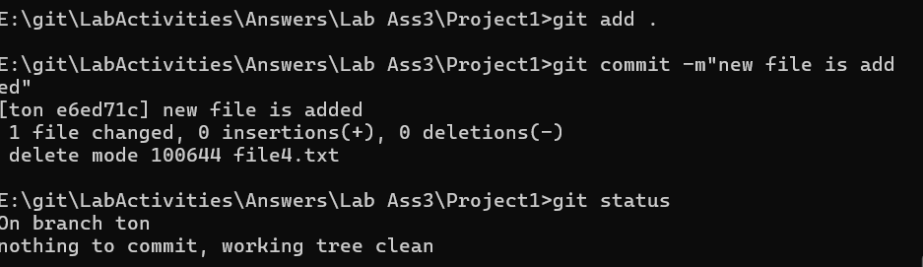

10. Return to master. Merge your branch. Notice how, thanks to the rebase, this is a fast-forward merge.

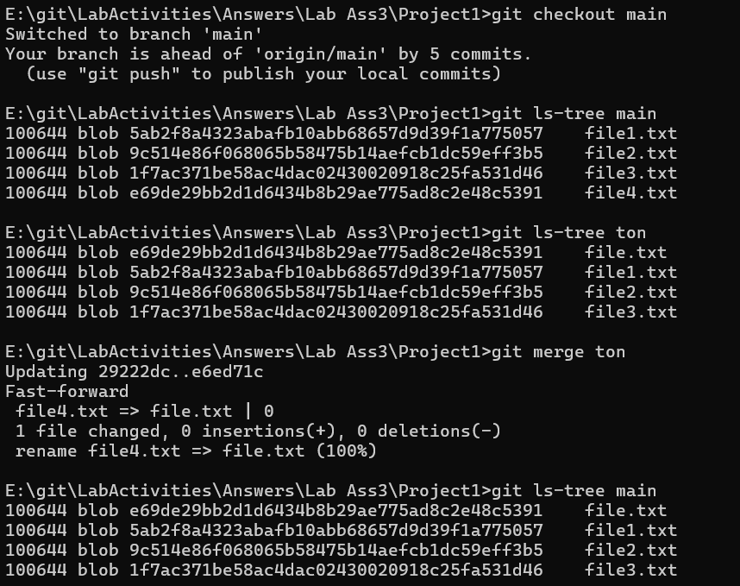

**Exercise 5**

Any time we have for this exercise, you are free to spend practicing whatever you find most interesting, or feel you have not fully grasped from the previous exercises and want another go through. Refer to the final section of the course for features you might like to explore.

Interesting parts,  
  
**1. This same person should then follow the instructions from GitHub to add a remote, and then push their repository. Do not forget the –u flag, as suggested by GitHub!**



**2. All of the other members of the group should then be added as collaborators, so they can commit to the repository also.**



**3. Next, everyone else in the group should clone the repository from GitHub. Verify that the context of the repository is what is expected.**



**4. One of the group members who just cloned should now make a local commit, then push it. Everyone should verify that when they pull, that commit is added to their local repository (use git log to check for it).**





**5. Look at each other’s git log output. Notice how the SHA-1 is the same for a given commit across every copy of the repository. Why is this important?**

It is the reference for all the users working on it.



**6. Two members of the group should now make a commit locally, and race to push it. To keep things simple, be sure to edit different files. What happens to the runner-up?**



All are Done,

Thankyou.